Technical Datasheet Input / Output Modules with MQTT Protocol with Ethernet Interface
The IO Module communicates via an Ethernet Interface and is designed to interface seamlessly with other MQTT-compatible devices. The module acts as an input/output device that bridges the MQTT network and the connected gateway, enabling real-time data exchange over the MQTT protocol.This Digital I/O module is robust, energy-efficient, and user-friendly, making it ideal for a wide range of IoT applications. It supports for digital inputs, and allows users to easily publish and subscribe to topics on an MQTT broker, facilitating communication with other devices, cloud platforms, and remote monitoring systems.
16 Port DI Module with Modbus TCP Ethernet: -
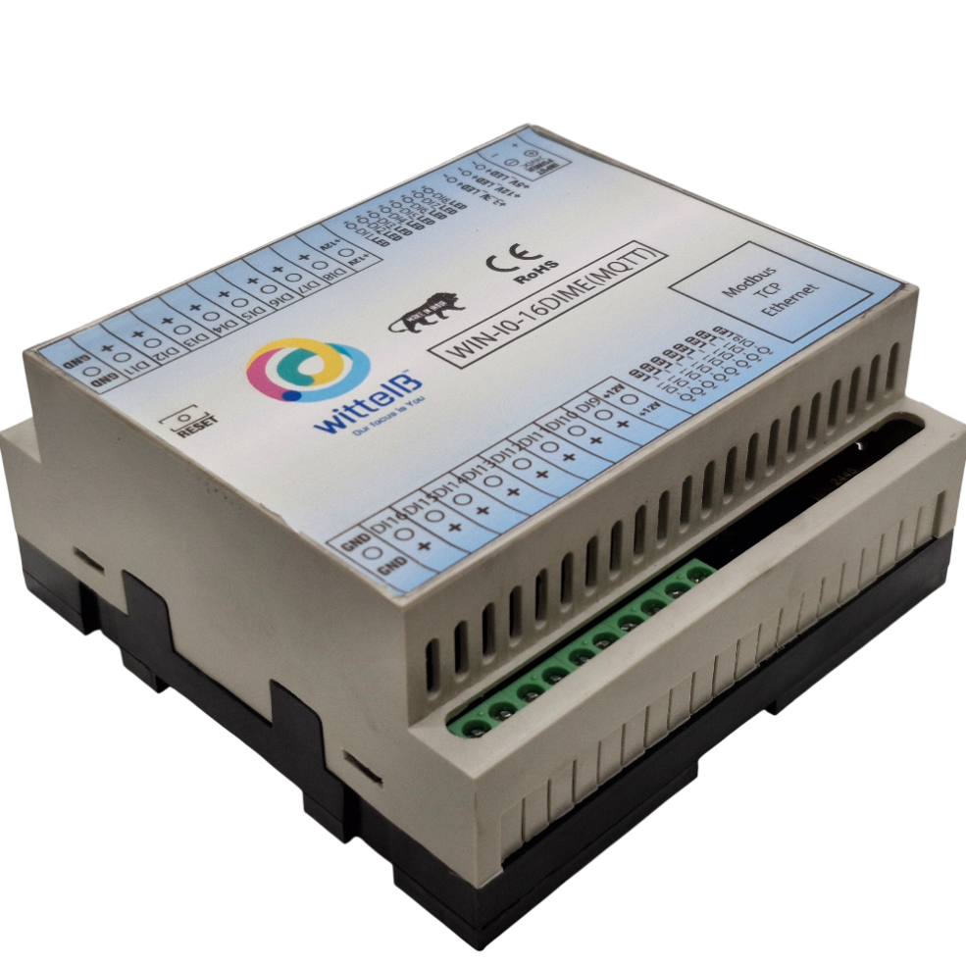
The IO modules enclosures are DIN rail Mountable. It’s a closed Enclosure with openings for connectors and LED indicators.
The design of the modules incorporates ‘resettable Fuses’ to safeguard against reverse polarity connection for Power Input.
There are LED indicators for each of the IO ports as well as for the module Power.

Specifications
General –

I/O Connectors 22 Pin 5.08 mm pitch pluggable screw Terminal Block, 2 Pin 5.08 mm pitch pluggable screw terminals.
Dimensions 110 mm L x 110 mm B x 50 mm H
Power Input Power – 12-24 V DC
Typical – 12V DC @ 120mA
Operating Temperature 0 – 60° C (32 ~ 140°F)
Storage Temperature -20 - 70° C (-4 ~ 158°F)
Storage Humidity 5 ~ 95 % RH, non – Condensing
Certifications 

DI Inputs –

Channels 16
Sense Voltage 3.3 – 30 VDC
Sense Logic Logic ‘0’ = <1 VDC, Logic ‘1’ = >3.3 VDC
Isolation Optically isolated
Response Time 2 msec, Max 6 msec

Technical Specifications:

Key Features
- MQTT Protocol Suport: Fully compliant with the MQTT protocol, supporting both MQTT 3.1.1 and MQTT 5.0.
- Ethernet Connectivity: Standard Ethernet port (10/100 Mbps) for stable and high-speed data transmission.
- Low Power Consumption: Optimized for low power usage, ideal for battery-operated or energy-efficient applications.
- Easy Integration: Supports standard libraries and tools for easy integration with existing systems.
- Message Retention & Quality of Service (Q o S): Supports various Q o S levels (0, 1, 2) to guarantee message delivery.
- Secure Communication: Support for TLS/SSL encryption for secure communication with MQTT brokers.
- Real-time Data Handling: Efficient, real-time messaging with minimal delay.
- Compact Form Factor: Small and lightweight, designed for embedded systems.
- Configuration Process:-
- For Configuration Enter IP 192.168.1.40.
- You will get this type of page as shown in the image(1.1)

- After Entering the ip You will see interface as shown in the image.
Note:- (For more help you can refer below image1.1 for login)

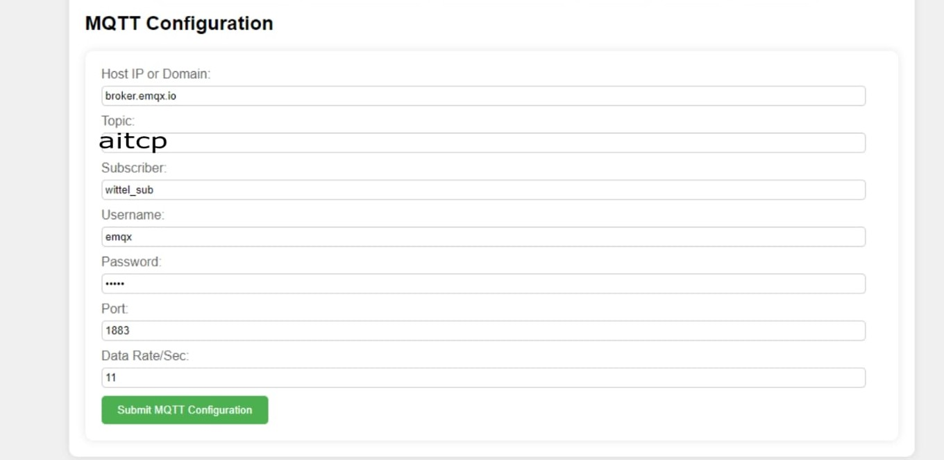

Login and MQTT Configuration : -
- Login Prompt
When you open the device's details page, you will be prompted to enter a username and password.
- Default Username
The default username is usually admin.
- Default Password
The default password is typically admin or password.
- MQTT Port
The default MQTT port is 1883 for unencrypted connections.
For secure MQTT over TLS, use port 8883.
- Topic Name
Ensure you configure the correct topic name where the analog and digital data will be published.
For example, if you set the topic to “aitcp”, you will receive analog and digital data on that topic.
- Data Rate
The data rate refers to how often the device publishes messages. You can set it to a specific interval, such as every second or every few seconds, depending on how often you want the data to update.
Note: (Username Password is optional).

- After submitting the data you will get data on on mqtt cloud.

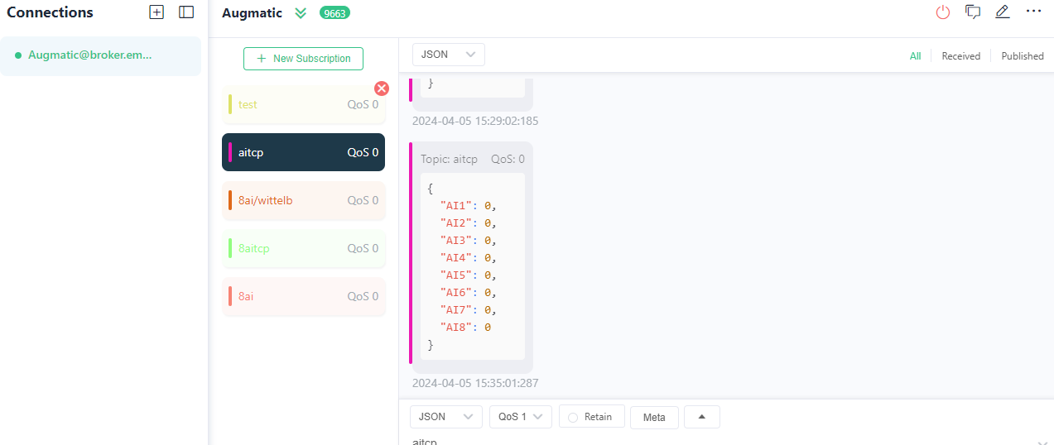

- Here you can see the data of analog input data same as you can see digital input data of 16 channel..

DI

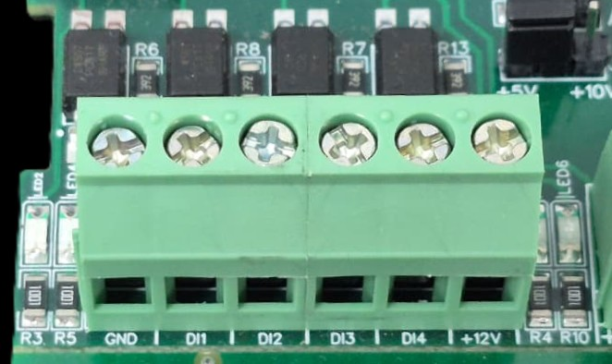
I/p device
I/p device
I/p device
I/p device

- Operation: The module provides four isolated input channels (DI1–DI4) for sensing external signals or dry contacts. These inputs are opto-isolated for circuit protection.
- Terminal Layout:
  - GND: Common Ground reference.
  - DI1 – DI4: Individual Digital Input channels.
  - +12V: Internal reference voltage for sourcing "Dry Contact" switches.
- Wiring Options:
  - Dry Contact: Connect a switch between the +12V terminal and any DI pin.
  - External Voltage: Connect the external signal to a DI pin and the external ground to the GND terminal.
- Voltage Rating: The input circuitry is rated for a maximum of 80VDC. Ensure external signals do not exceed this limit to prevent damage to the isolation ICs.

Digital input LED
+12V DI1 DI2 DI3 DI4 DI5 DI6 DI7 DI8 GND

GND DI16 DI15 DI14 DI13 DI12 DI11 DI10 DI9 DI8 +12V

Input 24 VDC

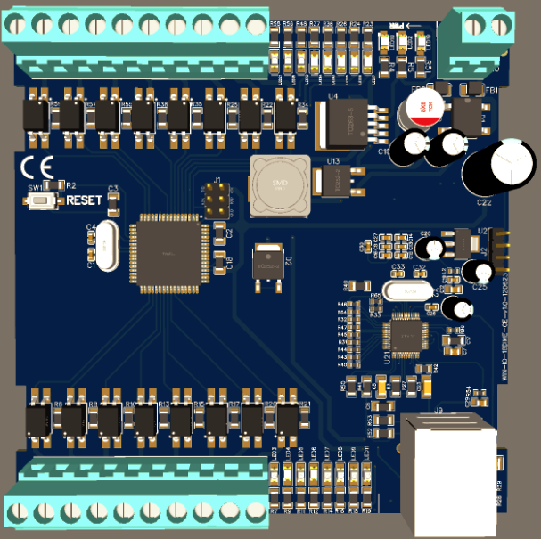
Ethernet Port

Contact us: -
Augmatic Technologies Pvt. Ltd.,
Plot no 6, Shah Industrial Estate II,
Kotambi,
Vadodara – 391510.
Email – Sales@wittelb.com
Support: support@wittelb.raiseaticket.com / +91 94038 92805

